**Upcoming Board Meetings:**

Friday; August 9th, 2024

@ 1:00 pm

(Moved from Monday due to Union County Fair/ Ranch Management Contest)

Monday; September 9th, 2024

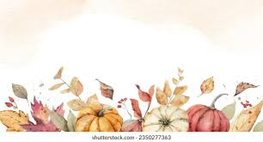@ 10:00 am

Monday; October 14th, 2024

@10:00 am

Monday; November 11th, 2024

@10:00 am

**Upcoming Board Meetings Continued:**

Monday; December 9th, 2024

@10:00 am